Module 7: Redshift Assignment
Problem Statement:
You work for XYZ Corporation. Their application requires a database service that
can store data which can be retrieved if required. Implement suitable service for
the same.
While migrating, you are asked to perform the following
tasks:
1. Create a Redshift data warehouse.
2. Using the query editor:
a. Load some data
b. Query the data

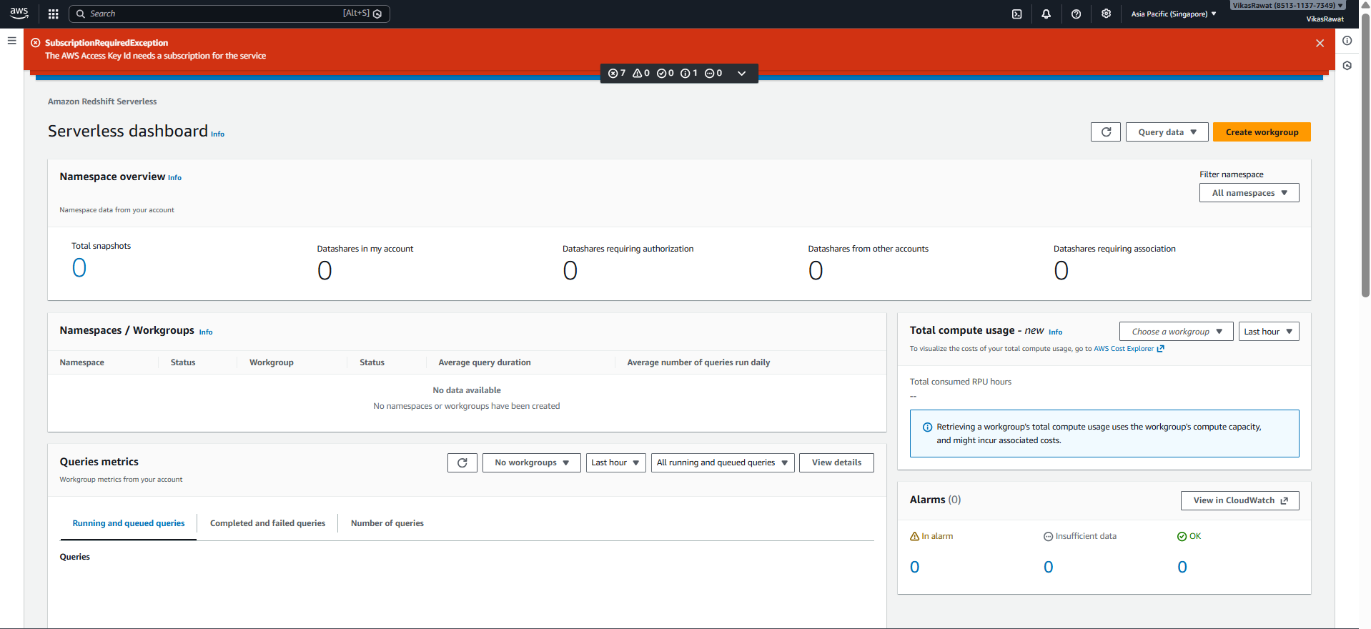

Service not available with Free account.

